**A PROJECT REPORT ON**

**HEART BEAT MEASURING USING ARDUINO**

***Submitted in accordance with the curriculum requirements for sixth semester of the degree course in***

**BACHELOR OF TECHNOLOGY**



*SUBMITTED BY*

D.NAVAKISHORE 14691A04B6 (ECE)

B.NAGASAI 14691A04B0 (ECE)

S.ALTHAF 14691A0204 (EEE)

V.ABHILASH NAIDU 14691A0201 (EEE)

***Under the guidance of***

**Mr. D. GIRISH KUMAR, M.Tech, Asst.Professor**

**DEPARTMENT OF ELECTRONICS AND COMMUNICATION ENGINEERING**

**AND**

**K.V.SATHEESH BABU, M.Tech, (Ph.D.) Asst.Professor**

**DEPARTMENT OF ELECTRICAL AND ELECTRONICS ENGINEERING**

**MADANAPALLE INSTITUTE OF TECHNOLOGY & SCIENCE**

**(UGC-Autonomous)**

(Approved by AICTE & Affiliated to JNTUA, Anantapuram)

ANGALLU, MADANAPALLE-517325

**MADANAPALLE INSTITUTE OF TECHNOLOGY & SCIENCE**

**(UGC-Autonomous)**

(Approved by AICTE & Affiliated to JNTUA, Anantapuram)

ANGALLU, MADANAPALLE-517325



**CERTIFICATE**

This is to certify that this mini project entitled **HEART BEAT MEASURING USING ARDUINO** has been completed by D,Navakishore, B.Nagasai, S. Althaf and V. Abhilash Naidu during sixth semester in partial fulfilment of the award of degree in **BACHELOR OF TECNOLOGY IN ECE AND EEE** during academic year 2016-2017

**PROJECT GUIDE PROJECT GUIDE Mr.D.Girish Kumar,M.Tech,Asst.Professor Mr.Sateesh Babu,M.Tech, PhD,Asst.Professor**

**Head of Department Head of Department**

**Dr. Thamarai, Dr. C. Kamal Basha, Professor (ECE) Assoc. Professor (EEE)**

**ACKNOWLDEGEMENT**

We wish to express our deep sense of gratitude to **Mr. D. Girish Kumar, M.Tech, Asst. Professor** In Electronics and Communication Engineering department and **Mr.K.V. Satheesh Babu, M.Tech, Asst. Professor** in Electrical and Electronics Engineering in MADANAPALLE INSTITUTE OF TECHNOLOGY AND SCIENCE(UGC- AUTONOMUS) angallu, Madanapalle, Chittoor. Who laid the time bond for the successful completion of this project. They challenged our thoughts and extended timely suggestions for which we are deeply indebted to them.

We are also expressing our sincere thanks to **Dr. Thamarai, Professor & HOD(ECE), Dr. C. Kamal Basha, Assoc. Professor & HOD(EEE)** for their esteemed support provided.

Also we would like to express our gratitude to faculty members of Electronics and Communication Engineering department, Electrical and Electronics Engineering and those who are directly or indirectly helped us in successful completion of our project.

ABSTRACT

This project describes the design of a simple, low cost microcontroller based heartbeat monitoring device through a fingertip and Arduino board with the LCD output. In this project we measure the physical parameters like heartbeat rate per minute with help of the bio-sensors like pulse rate sensor (heart beat sensor module), which contains IR-infrared and Photo diode sensor

Heart rate measurement is one of the very important parameters of the human cardiovascular system. The heart rate of a healthy person is around 72 bpm, Babies at around 120bpm, while older children have heart rates around 90bpm. It is not possible for a doctor to observe a patient’s heart rate per minute, so that the reason we doing this project. The main application of this project is in Medicine and Health serious conditions.

INDEX

## S. NO. CHAPTER NAME

1. INTRODUCTION

2. COMPONENTS

2.1 Arduino

2.2 16×2 LCD

2.3 Heart Beat Sensor Module

2.4 Bread Board

2.5 Push Buttons

2.6 RESISTORS

2.7 RPS (Power supply)

3. BLOCK DIAGRAM

3.1BLOCK DIAGRAM OF HEART BEAT SENSOR MODULE AND ARDUINO

3.2 BLOCK DIAGRAM OF LCD AND ARDUINO

3.3 MAIN BLOCK DIAGRAM

3.4 CIRCUIT DIAGRAM AND EXPLANATION

4. WORKING

5. 5.1 APLLICATIONS

5.2 ADVANTAGES

6. CONCLUSION

7. REFERENCES

1. INTRODUCTION

A heart rate monitor is a personal monitoring device that allows a subject to measure their heart rate in real time or record their heart rate for later study. Early models consisted of a monitoring box with a set of electrode leads that attached to the chest. The heart rate of a healthy adult at rest is around 72 beats per minute (bpm) & Babies at around 120 bpm, while older children have heart rates at around 90 bpm. The heart rate rises gradually during exercises and returns slowly to the rest value after exercise. The rate when the pulse returns to normal is an indication of the fitness of the person. Lower than normal heart rates are usually an indication of a condition known as bradycardia, while higher is known as tachycardia. Heart rate is simply measured by placing the thumb over the subject’s arterial pulsation, and feeling, timing and counting the pulses usually in a 30 second period. Heart rate (bpm) of the subject is then found by multiplying the obtained number by 2. This method although simple, is not accurate and can give errors when the rate is high. More sophisticated methods to measure the heart rate utilize electronic techniques. Electro-cardiogram (ECG) is one of frequently used method for measuring the heart rate. But it is an expensive device. Low-cost devices in the form of wrist watches are also available for the instantaneous measurement of the heart rate. Such devices can give accurate measurements but their cost is usually in excess of several hundred dollars, making them uneconomical. So this heart rate monitor with a temperature sensor is definitely a useful instrument in knowing the pulse and the temperature of the subject or the patient.

2. COMPONENTS

2.1 Arduino:

A program for Arduino may be written in any programming language for a compiler that produces binary machine code for the target processor. Atmel provides a development environment for their microcontrollers, AVR Studio and the newer Atmel Studio. The Arduino project provides the Arduino integrated development environment (IDE), which is a cross plat from application written in the programming language java. It originated from the IDE for the languages processing and *wiring*. It includes a code editor with features such as text cutting and pasting, searching and replacing text, automatic indenting, brace matching, and syntax high lighting, and provides simple *one-click* mechanisms to compile and upload programs to an Arduino board. It also contains a message area, a text console, a toolbar with buttons for common functions and a hierarchy of operation menus. A program written with the IDE for Arduino is called a *sketch*. Sketches are saved on the development computer as text files with the file extension. Arduino Software (IDE) saved sketches with the extension.

The Arduino IDE supports the languages C and C++ using special rules of code structuring. The Arduino IDE supplies a software library from the wiring project, which provides many common input and output procedures. User-written code only requires two basic functions, for starting the sketch and the main program loop that are compiled and linked with a program stub *main* into an executable cyclic executive program with the GNU tool chain, also included with the IDE distribution. The Arduino IDE employs the program *argued* to convert the executable code into a text file in hexadecimal encoding that is loaded into the Arduino board by a loader program in the board's firmware.

2.2 16*2 LCD DISPLAY:

LIQUID CRYSTAL DIPLAY is allows known as LCD. It is a flat panel display or other electronically modulated optical device that uses the light-modulating properties of LCD.LCD do not emit light directly, instead using a black light or reflector to produce images in colour or monochrome LCDs are available to display arbitrary images with low information content. Which can be displayed or hidden, such as preset words, digits, and 7-segment displays, as in a digital clock. They use the same basic technology, except that arbitrary images are made up of a large number of small pixels, while other displays have larger elements.

LCDs are used in a wide range of applications including computer monitors, televisions, instrument panels, air craft cockpit displays and indoor and outdoor signage. Small LCD screens are common in portable consumer devices such as digital cameras, watches, calculators, and mobile telephones, including smart phones. LCD screens are also used on consumer electronics products such as DVD players, video game devices and clocks. LCD screens have replaced heavy, bulky cathode ray tube (CRT) displays in nearly all applications. LCD screens are available in a wider range of screen sizes than CRT and plasma displays, with LCD screens available in sizes ranging from tiny digital watches to huge, big-screen television set. Since LCD screens do not use phosphors, they do not suffer image burn in when a static image is displayed on a screen for a long time (e.g., the table frame for an aircraft schedule on an indoor sign). LCDs are, however, susceptible to image persistence. The LCD screen is more energy-efficient and can be disposed of more safely than a CRT can. Its low electrical power consumption enables it to be used in battery powered electronic equipment more efficiently than CRTs can be. By 2008, annual sales of televisions with LCD screens exceeded sales of CRT units worldwide, and the CRT became obsolete for most purposes.

2.3 HEART BEAT SENSOR MODULE:

The module uses an infrared led (IR) and a photo transistor to detect the pulse of the finger and whenever a pulse is detected, red led flashes. There will be led on the light side of the finger and a photo transistor on the other side of the finger. Photo transistor is used to obtain the flux emitted. The resistance of the photo resistor will change when the pulses will change.

The sensor unit consists of an infrared light-emitting-diode (IR LED) and a photo diode, placed side by side, and the fingertip is placed over the sensor assembly, as shown below. The IR LED transmits an infrared light into the fingertip, a part of which is reflected back from the blood inside the finger arteries. The photo diode senses the portion of the light that is reflected back. The intensity of reflected light depends upon the blood volume inside the fingertip. So, every time the heart beats the amount of reflected infrared light changes, which can be detected by the photo diode. With a high gain amplifier, this little alteration in the amplitude of the reflected light can be converted into a pulse.

2.4 BREAD BOARD:

A **breadboard** is a construction base for [prototyping](https://en.wikipedia.org/wiki/Prototype) of [electronics](https://en.wikipedia.org/wiki/Electronic_circuit). Originally it was literally a bread board, a polished piece of wood used for slicing bread. In the 1970s the **solderless breadboard with 400 connection points** (AKA **plug board**, a terminal array board) became available and nowadays the term "breadboard" is commonly used to refer to these.

Because the solderless breadboard does not require [soldering](https://en.wikipedia.org/wiki/Soldering), it is reusable. This makes it easy to use for creating temporary prototypes and experimenting with circuit design. For this reason, solderless breadboards are also extremely popular with students and in technological education. Older breadboard types did not have this property. A [stripboard](https://en.wikipedia.org/wiki/Stripboard) (Vero board) and similar prototyping [printed circuit boards](https://en.wikipedia.org/wiki/Printed_circuit_board), which are used to build semi-permanent soldered prototypes or one-offs, cannot easily be reused. A variety of electronic systems may be prototyped by using breadboards, from small analog and digital circuits to complete.

2.5 PUSH BUTTONS:

A **push-button** (also spelled **pushbutton**) or simply **button** is a simple [switch](https://en.wikipedia.org/wiki/Switch) mechanism for controlling some aspect of a [machine](https://en.wikipedia.org/wiki/Machine) or a [process](https://en.wikipedia.org/wiki/Process_(engineering)). Buttons are typically made out of hard material, usually [plastic](https://en.wikipedia.org/wiki/Plastic) or [metal](https://en.wikipedia.org/wiki/Metal). The surface is usually flat or shaped to accommodate the human finger or hand, so as to be easily depressed or pushed. Buttons are most often [biased switches](https://en.wikipedia.org/wiki/Switch#Biased_switches), although many un-biased buttons (due to their physical nature) still require a [spring](https://en.wikipedia.org/wiki/Spring_(device)) to return to their un-pushed state. Different people use different terms for the "pushing" of the button, such as **press**, **depress**, **mash**, **hit**, and **punch**.

2.6 RESISTORS:

A **resistor** is a passive two component terminal electrical component that implements electrical resistance as a circuit element. In electronic circuits, resistors are used to reduce current flow, adjust signal levels, to divide voltages, bias active elements, and terminate transsimon lines, among other uses. High-power resistors that can dissipate many watts. of electrical power as heat may be used as part of motor controls, in power distribution systems, or as test loads for generators. Fixed resistors have resistances that only change slightly with temperature, time or operating voltage. Variable resistors can be used to adjust circuit elements (such as a volume control or a lamp dimmer), or as sensing devices for heat, light, humidity, force, or chemical activity. Resistors are common elements of electronic networks and electronic circuits and are ubiquitous in electronic equipment.

Practical resistors as discrete components can be composed of various compounds and forms. Resistors are also implemented within integrated circuits. The electrical function of a resistor is specified by its resistance: common commercial resistors are manufactured over a range of more than nine orders of magnitude. The nominal value of the resistance falls within the manufacturing tolerance, indicated on the component.

2.7 RPS

AREGULATED POWER SUPPLY is an embedded circuit; it converts unregulated AC into a constant DC. With the help of a rectifier it converts AC supply into DC. Its function is to supply a stable voltage (or less often current), to a circuit or device that must be operated within certain power supply limits. The output from the regulated power supply may be alternating or unidirectional, but is nearly always DC.

The type of stabilization used may be restricted to ensuring that the output remains within certain limits under various load conditions, or it may also include compensation for variations in its own supply source. The latter is much more common today.

3. BLOCK DIAGRAMS

3.1 Block Diagram of Heart Beat Sensor Module and Arduino

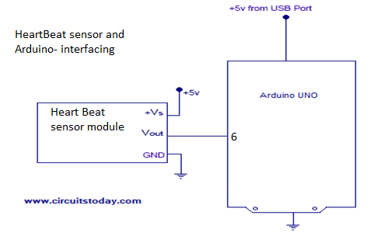

3.2 Block Diagram of LCD and Arduino

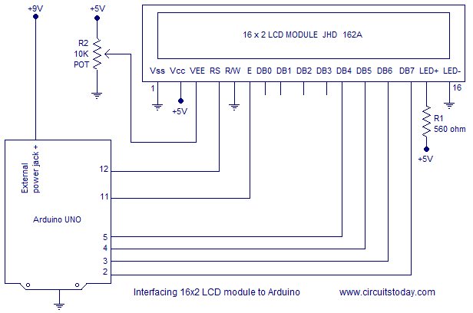

3.3 Main Block Diagram

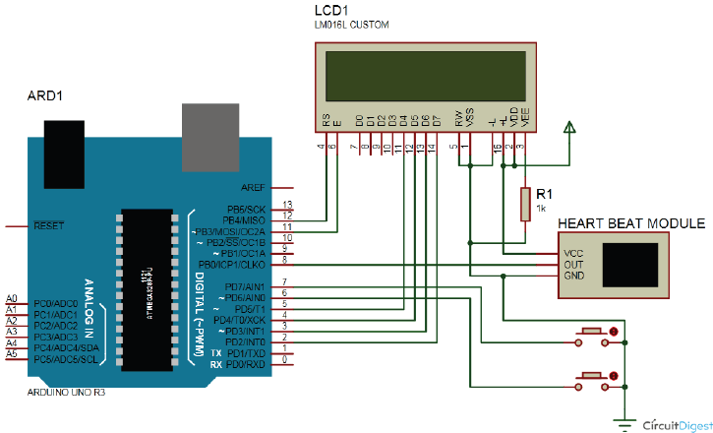

3.4 Circuit Diagram and Explanation

Circuit of heartbeat monitor is shown below, which contains Arduino Uno, heart beat sensor module, reset button and LCD. Arduino controls whole the process of system like reading pulses form Heart beat sensor module, calculating heart rate and sending this data to LCD. We can set the sensitivity of this sensor module by inbuilt potentiometer placed on this module.

Heart beat sensor module’s output pin is directly connected to pin 8 of Arduino. Vcc and GND are connected to Vcc and GND. A 16x2 LCD is connected with Arduino in 4-bit mode. Control pin RS, RW and En are directly connected to Arduino pin 12, GND and 11. And data pin D4-D7 is connected to pins 5, 4, 3and 2 of Arduino. And one push button is added for resetting reading and another is used to start the system for reading pulses. When we need to count heart rate, we press start button then Arduino start counting pulses and also start counter for five seconds. This start push button is connected to pin 7 and reset push button is connected to pin 6 of Arduino with respect to ground.

4. WORKING:

Working of this project is quite easy but a little calculation for calculating heart rate is required. There are several methods for calculating heart rate, but here we have read only five pulses. Then we have calculated total heart beat in a minute by applying the below formula:

Five_pusle_time=time2-time1;

Single_pulse_time= Five_pusle_time /5;

Rate = 60000/ Single_pulse_time;

Where time1 is first pulse counter value

time2 is list pulse counter value

Rate is final heart rate.

When first pulse comes, we start counter by using timer counter function in Arduino that is millis();. And take first pulse counter value form millis();.Then we wait for five pulses. After getting five pulses we again take counter value in time2 and then we subtract time1 from time2 to take original time taken by five pulses. And then divide this time by 5 times for getting single pulse time. Now we have time for single pulse and we can easily find the pulse in one minute, dividing 600000 ms by single pulse time.

Rate= 600000/single pulse time.

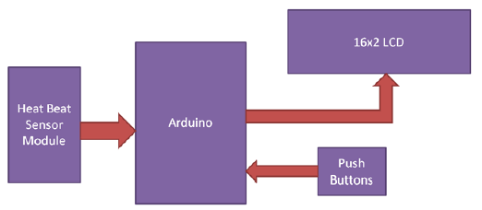

In this project we have used Heart beat sensor module to detect Heart Beat. This sensor module contains an IR pair which actually detect heart beat from blood. Heart pumps the blood in body which is called heartbeat, when it happens the blood concentration in body changes. And we use this change to make a voltage or pulse electrically.

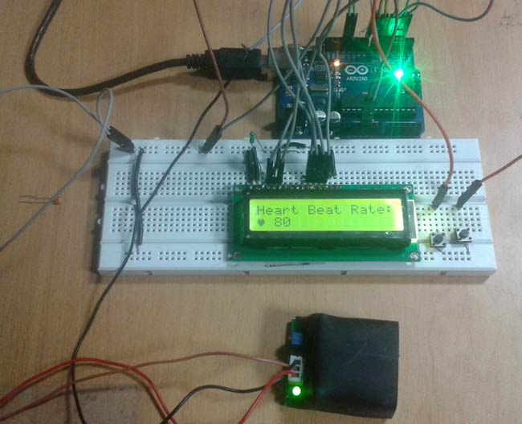

5.1 APPLICATIONS:-

1. In Medicine
2. Health serious conditions
3. Works as a Digital Heart Rate monitor
4. The device has the advantage that it can be used by non-professional people at home to measure the heart rate and body temperature easily and safely.
5. For old persons this project is helpful, because they are unable to go to the hospital always.
6. More than 2 million people are at high risk of having heart attack for those people this device is somewhat useful.

5.2 ADVANTAGES:-

1. Construction is easy.

2. Power consumption is low.

3. Easy to maintain.

6. CONCLUSION

Biomedical engineering (BME) combines the design and problem solving skill of engineering with medical and biological sciences to improve patient’s health care and the quality of life of individuals. Cardiovascular disease is one of the major causes of untimely deaths in world, heart beat readings are by far the only viable diagnostic tool that could promote early detection of cardiac events. By using this we can measure ones heart rate through fingertip.

7. REFERENCES

1. Souvik Das “The Development of a Microcontroller Based Low Cost Heart Rate Counter for Health Care Systems” International Journal of Engineering Trends and Technology- Volume4Issue2- 2013.

2. Embedded Lab. Introducing Easy Pulse: A DIY photoplethysmographic sensor for measuring heart rate. http://embedded-lab.com/blog/?p=5508, 2012.

3. Embedded Lab “Arduino measures heart beat rate from fingertip”

4. WWW.DATASHEETS.COM

5. WWW.CIRCUITSTODAY.COM